Erik Ostlind

Jeo170030

**3340 Project**

**Tetris**

This program is a recreation of the classic game Tetris. It is a complete functioning multicolor game with a score board display.

**Requirements**

* Mars4_5.jar
* Project folder containing the following files

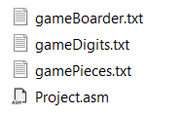

**Instructions**

1. Place the ‘Project’ folder in the same directory as the Mars4_5.jar file
2. Open Mars and open the ‘Project.asm’ file
3. Open the ‘Tools’ menu

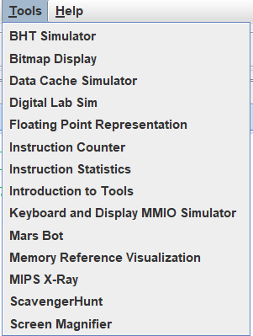

1. Select ‘Bitmap Display’. The following should pop up

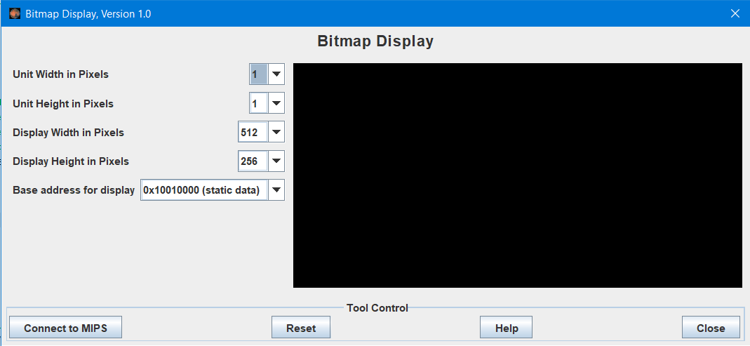

1. Set ‘Unit Width in Pixels’ and ‘Unit Height in Pixels’ to 16
2. Set ‘Display Width in pixels’ to 256 and ‘Display Height in Pixels’ to 512
3. Then resize the ‘Bitmap Display’ window so that all of the black area is visible. It should look similar to this.

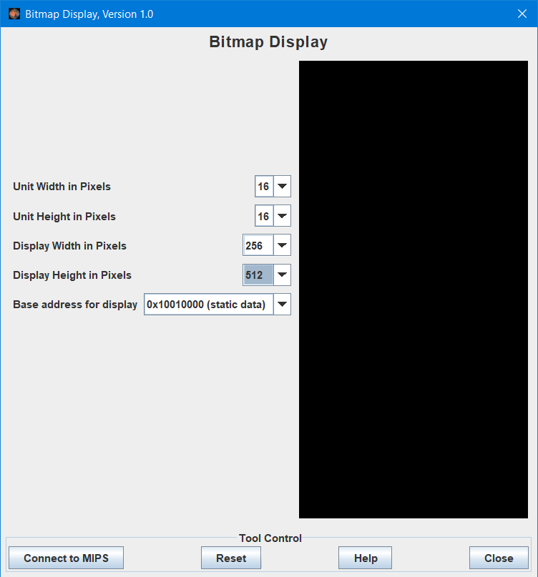

1. Then click ‘Connect to MIPS’. It should display the ‘Disconnect from MIPS’ after being clicked.



1. Next open the ‘Tools’ menu again and select ‘Keyboard and Display MMIO Simulator’. The following should pop up

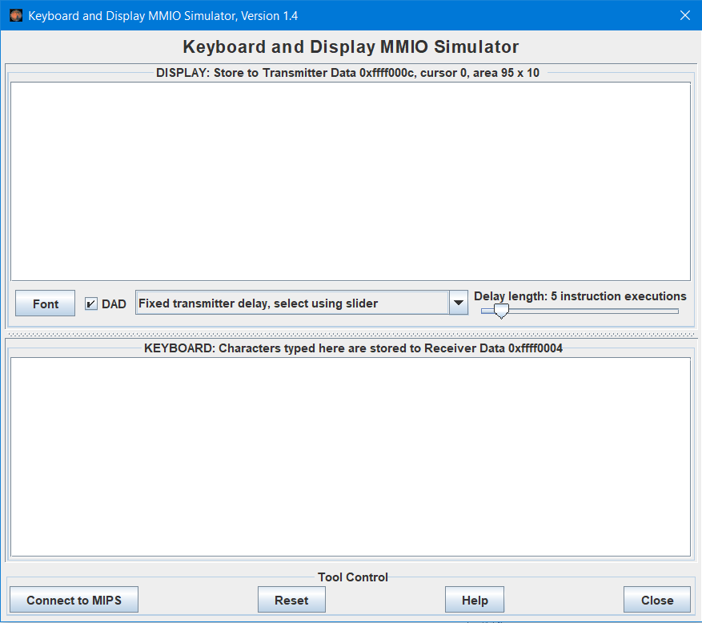

1. Then click ‘Connect to MIPS’. You may also want to resize this window so that you have more space.

**Running the Game**

1. Next click ‘Assemble the current file and clear breakpoints’



1. Then click ‘Run current program’



1. The Bitmap display is where the game will be displayed. The following is an example of the program successfully starting.

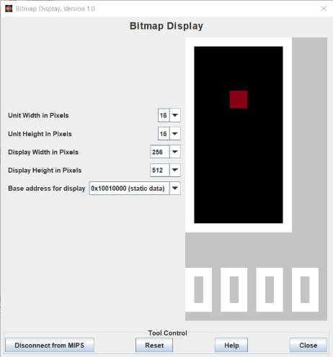

1. To interact with the game, click inside of the ‘KEYBOARD’ area of the ‘Keyboard and display MMIO Simulator’ and press the desired keys.

**Controls**

* W: Rotate piece
* A: Move left
* S: ~~Move down faster~~ **Buggy Don’t Use**
* D: Move right

**Objective**

The game is Tetris. If you have never played before the objective of the game is to score as many points as possible before the blocks reach the top. Points are scored when a row is filled. The row is then deleted, and point is awarded.

**Trouble Shooting**

* Game runs but nothing happens
  + If this is the case, check the ‘Run I/O’ output window in Mars. If a message similar to this “Failed to read file: Project/gameDigits.txt” appears. It means that you don’t have the full project folder and containing files or that the project folder is not in the same directory as the ‘Mars4_5.jar’ file.
* **WARNING**: Do not hold a key down for longer than a few seconds, it may cause Mars to hang and can only be closed through the ‘Task Manager’. If this happens close the program ‘Java(TM) Platform SE binary’. Once closed you will have to reopen Mars and follow the previous steps again.

